Challenge 7

Suggested Tips from Instructor Team

Use the DC Power Supply to provide the 5.0V power input to the device

Read the device output with Multimeter and/or Oscilloscope

Use the breadboard to make your wiring connections easier to track

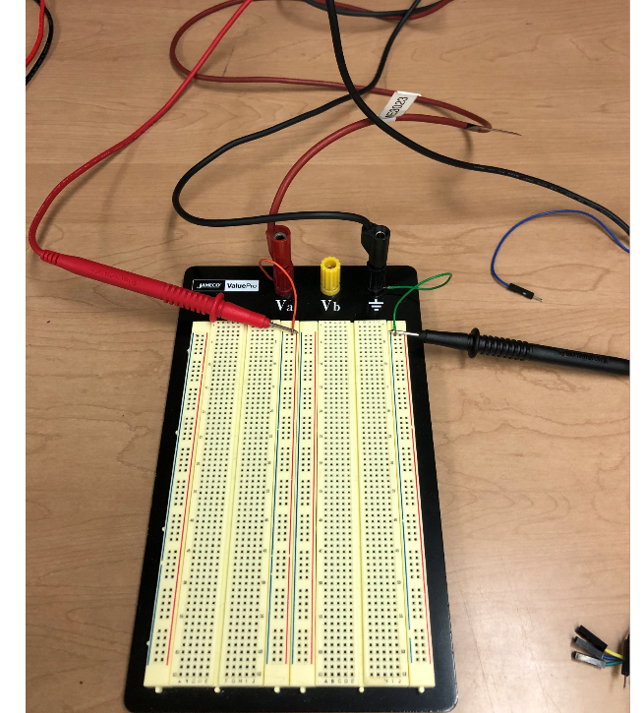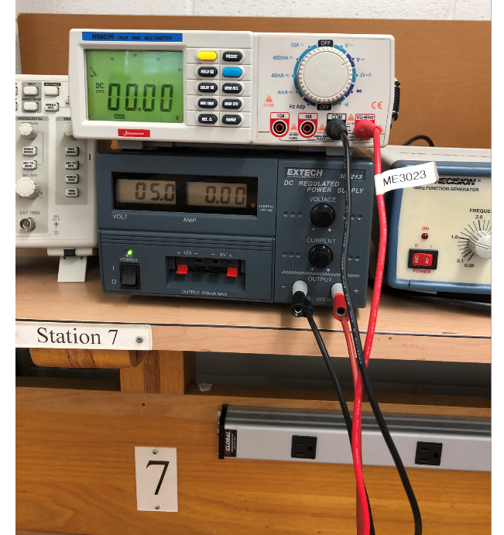

You should check to make sure you are getting 5V onto the breadboard. The photo above shows need to check wiring connections. 5V was being delivered to the breadboard, but could not see the value on the multimeter. Once the wires were adjusted to seat better into the board and making sure the probes were contacting well, 5 volts readout was indicated on the multimeter.

Now you are ready to get the 5 volts over to the force sensor using the breakout connector as shown in the other Tips document.

AND you can also connect the OUTPUTS from the breakout into the o-scope or multimeter to see the output voltage from the force gage. You will need the negative (ground) signal line as well, so one way to do that is pictured below.

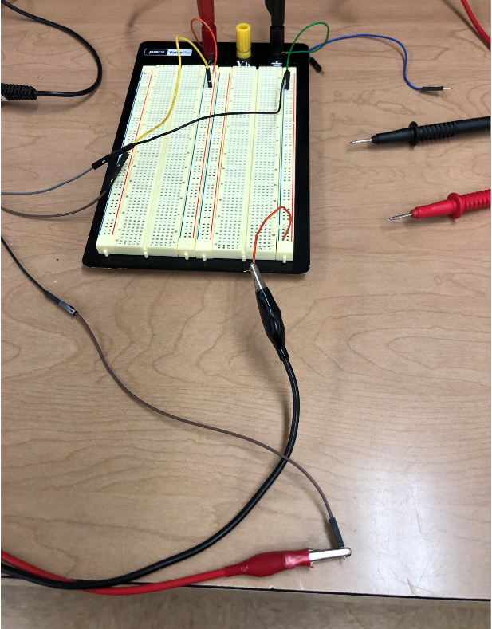

The photo below offers one possible way for you to configure your overall setup

